ABDUL BASIT(46658)

REPORT LAB AFTER MID:

TASK NO 1:

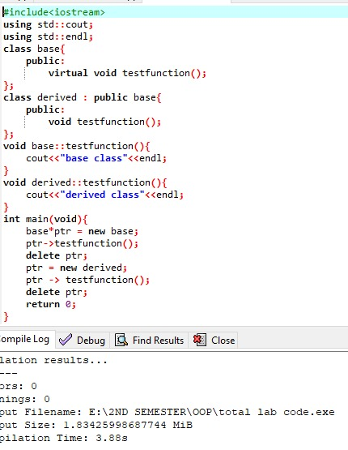

OUTPUT:

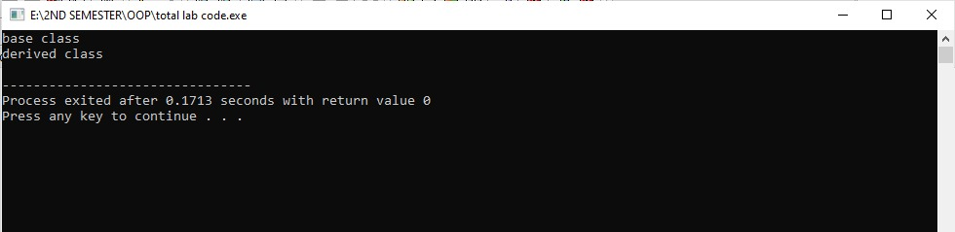

TASK NO 2:

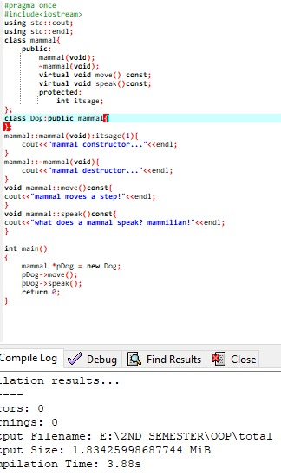

OUTPUT:

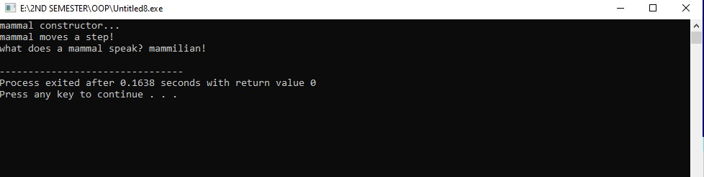

There was an error in the beginning.The dog was not inherited with class mammal.Then we inherited the dog with mammal class and solved the error.

**TASK 03:**

